Population Dynamics in Greenland - Sex, Intimacy and Relationships

Date of the interview: September 22nd, 2015
Name of the interviewer: Majbritt Didriksen Raal
Record No.: 150922_0043

SIR # 15

Section 1: General (Section:)

1. How old are you?
24 years old.
2.Where do you live?
Kullorsuaq.

3. Who do you live with?
My parents and my siblings.

4. How many children do you have?
Two.

5. What is your education?
Now in the later years I am not getting an education. I have completed the public school.

6. What do you do for a living?
I don’t do anything; I have tried to find a job but I haven’t succeeded in finding a job yet.

Section 2: Opinions about Sex, Pregnancy and Contraception (Section:)

1. What are some reasons young people in Kullorsuaq decide to have sex?
I don’t know how to respond to that. I don’t know maybe most of them are with some like they think is nice and beautiful.

2. What do you think are some reasons young people in Kullorsuaq decide not to have sex?
It is hard to answer that I can’t guess why.

3. What do you think are some reasons young people in Kullorsuaq decide to use contraception (like condoms, birth control pills, Depo-Provera, etc.) to prevent pregnancy?
Maybe most of the men want to use the condoms and the women I don’t know, the use condom to protect themselves against STD’s.

4. What do you think are some reasons young people in Kullorsuaq decide not to use contraception to prevent pregnancy?
I don’t know how to guess that, most may use contraception’s or not, I don’t know that.

5. What do you think are some reasons that young people in Kullorsuaq decide to delay parenting until after their teenage years? Or opposite; decide to become parents as teenagers?
I think that only happens when in they are in a relationship and have made an agreement to wait. One of the reason for waiting could be ready first or when one can provide for oneself.

6. How are reasons for both using and not using contraception different for females versus males? For example, why might a female want to use contraception to prevent a pregnancy? And why might a male want to use a condom or have the female he is having sex with use contraception to prevent a pregnancy?
Most may do that to protect themselves, because they don’t want to have children and because they want to avoid getting STD’s.

Section 3: Personal Understanding About Sex, Pregnancy, and Contraception (Section:)

1. How did you learn about sex? Who taught you about sex?
I don’t know how to answer that. When I was in public school it was one of the subjects. I first tried it when I first was in school at Upernavik I learned by doing there.

2. What did you learn about sex?
Different nice things and disappointments, different things.

3. How did what you learned about sex when you were young differ from what you understand about sex today?
Yes, there is a great difference for example, when one is young it is easy to go from one to another, trying to experience something new, in the later years trying to be faithful.
MDR: What is the purpose of being true? When one has a partner it is not good to be unfaithful.

4. What did you learn when you were young about what happens when a female gets pregnant? How did you learn this?
When I first got someone pregnant, they are not the same, then the partner changes. The woman begins to be moody, get easily angry, easy to cry and need intimacy.
I learned by experiencing my partner’s pregnancy, learning by doing.

5. How did/do you learn about contraception? What did/do you learn about contraception?
We used to have those in school part of the sexual education and then for men, condoms and how to protect oneself. I don’t know but I mentioned that earlier that they prevent pregnancies and STD’s.

6. Did/do you use contraception? Why or why not?
Yes, I use condoms sometimes, when I have partner I don’t use condoms, I can use condoms sometimes. It depends on the partner whether or she wants me to use condoms.

7. Describe the kinds of relationships you see in Kullorsuaq. Are they healthy or unhealthy? What makes them healthy or unhealthy?
They are different, we have not been too social with people here, we mainly stay home and visit with our family. I don’t know about others.
Most are probably healthy and fewer are not healthy.

8. Please describe one experience or more than one experience that had a strong influence on your feelings about sex?
I have never experienced anything that had strong influence on me.

9. Please describe one experience or more than one experience that had a strong influence on your feelings about pregnancy and having children?
When I first had my child, I didn’t believe that it was mine, because she has had another partner at the time of when she got pregnant. Entire time she was pregnant she thought it was someone else’s but she realized it was mine when she was eight months pregnant, we had a blood test, I haven’t experienced that at first. But lately I spend time with my child at birthdays, it is very nice, knowing that it is mine, my child lives with the mother.

10. Please describe one experience or more than one experience that had a strong influence on your feelings about your use of contraception? (For males - Please describe one experience or more than one experience that had a strong influence on your feelings about using a condom or having your partner/girlfriend/wife use contraception).
My partner gets a shot and I don’t mind, it is up to her how she wants to use contraception. It doesn’t have a strong influence on my feelings, I accept it.

Section 4: Relationships (Section:)

1. What do you think males and females in Kullorsuaq want in a relationship? What are the differences/similarities in what males want to have in a relationship versus females?
Most may, I don’t know how to explain that. We met each other after have been seeing each other for a long time, we developed feelings for each other. If I were to find a partner today, I would probably look for normal traits and kindness in that woman. I think what women want in a man differ from what I want in a woman, it could be different, maybe they would limit one more or be accepting of everything, depending on who they are.

2. What makes someone desirable? What are the differences/similarities in what makes a male desirable versus a female?
Maybe, a woman’s well shaped body.
I don’t know I expect it to be similar.

3. What makes someone a good partner? What are the differences/similarities in what makes a male a good partner versus a female?
Maybe, one that is loving, respectful and helpful. I think.
Surely we are different from person to person, then there could be differences, one could be good and the other bad or both good.

4. What makes a relationship good? What makes you happy in a relationship?
Giving love, respecting one another and intimacy.
It makes me happy to receive intimacy and love, those makes me happy.

5. What are some problems that come up when trying to develop a relationship?
There are different problems, for example, lack of own home, feeling comfortable at home is more what we want, lack of work/jobs are some problems one meets here in Kullorsuaq.

6. In which way do males and females in Kullorsuaq support each other in their relationships?
Maybe most support each other, like, if I am a hunter then supporting me could make want to hunt more, or if I am a sportsman, they are different.
I try to support her if she wants to do sports I would support her, something nice.
Maybe, one that works while the other one takes care of the children, they can help each other like that and also if one is not working than the other one is working.

7. Why do you think someone in Kullorsuaq stays with a partner who does not treat them well? (by doing things like lying, going around with other people, not communicating with them).
I don’t know, maybe it all depends on love. No caring for other because we love each other.

8. What are your options to find a good partner?
There may be opportunities, maybe by walking women home and ask them. There are possibilities but it all depends on what the woman thinks. There is abundance of opportunities.

9. Where do people find partners in Kullorsuaq?
Some find their partners in the south or here.

10. How do people date in Kullorsuaq? What do they do? Where do they go?
Mostly people meet with their friends at home or some other place. They socialize, playing games amongst men, playing football and amongst women that I don’t know.

11. If you had a chance to give relationship advice to a young person in Kullorsuaq what would you say to them? Is there a difference in what you would say to a male versus a female? And if there is a difference what is it and why?
That is hard for me answer, I can advice them that it is good to have a nice and happy relationship and be respectful.
It could be, women are different, but the above can be used for both.

12. Where did you learn about relationships? Who or what taught you about relationships?
While I was in school in Upernavik, I tried having relationships with different women.

Section 5: Love (Section:)

1. Describe what you believe romantic love is and what it involves.
It could be living together happy and cheerful, when separate missing each other, be lonely. We do things together and hug each other and have fun.

2. How did you learn about the type of love you just described?
It is something I have learned when I in the previous years had relationships, I think that is what I base it on.

3. Describe how you met your most recent or current partner/spouse/girlfriend/boyfriend?
I don’t really remember that, also because it is a long time ago, I forgot. She is from here, I think I have been with her since 2012, but we have parted and got back together many times.

4. Discuss how your most recent or current relationship compares to your ideal loving relationship.
Maybe it could have been nicer, there is some area to improve compared to my ideal. It could get better by talking together, it could get better.

5. What do you like about your current/most recent relationship?
We have children and I can’t leave her and when I am near her I am happy.

6. What do you not like about your current/most recent relationship?
I don’t like to be lied to, and the fact that she doesn’t respect enough.

7. Discuss the importance to you of staying in your current relationship.
The main importance may be that we have children together and that we should keep on going for our goals.

8. Can someone have sex without loving the person they are having sex with? What is your opinion about this?
Yes, it is possible. When I don’t have a partner, I can have sex with someone without loving them, but I can’t do that when I have a partner.

Section 6: Intimacy (Section:)

1. How are you and your partner/spouse/girlfriend/boyfriend intimate with each other?
We are mostly when we are at home or when we are visiting somewhere to socialize to have fun.

2. Describe the different between being sexually intimate with someone verses being emotionally intimate with someone?
I don’t know how to talk about those. I don’t really think about such things. Emotional intimacy is when we are close and cuddling. Emotional intimacy can be with anyone and sexual intimacy is mainly with the sexual partner.

3. Under what circumstances have you felt closest to your partner/spouse/girlfriend/boyfriend? Why was this?
Maybe when I am having a hard time. When we need something.

4. Describe when your partner/spouse/girlfriend/boyfriend has attempted to make you feel better? Was he/she successful at making you feel better? Why or why not? And did this create more intimacy in your relationship? Why or why not?
Maybe around the time we were having our child, we agreed and both said yes. My life has been lately evolved around wanting to work looking or a job to achieve all the obstacles makes it hard and unattainable. I can’t think of if she has done that.

5. In what way or ways did your intimate relationship with your partner/spouse/girlfriend/boyfriend influence your decision to have children?
I don’t know, maybe it happened more all of a sudden. It maybe, maybe we just wanted to keep it.

6. How did having children influence the intimacy in your relationship with your partner/spouse/girlfriend/boyfriend?
Maybe it we got happier and we became more intimate with each other.

Section 7: Experiences in Relationships (Section:)

1. Discuss a situation in which you and your partner/spouse/girlfriend/boyfriend disagreed about something? How did you resolve the conflict? Describe how you and your partner/spouse/girlfriend/boyfriend resolve conflict?
We have had many disagreements, for example when I wanted to go do sport and my partner disagrees or when she wants to go dance and I disagree with her, there are many different disagreements.
We talk about our disagreements and can move on after that.
We use conversation, talk to each other when we want to resolve our conflicts.

2. Describe one or more than one experience with your partner/spouse/girlfriend/boyfriend that you felt was hurtful, or violent or abusive?
She has hurt me but I don’t remember exactly how. She had been violent with me but not that much, I don’t know why she did that. I don’t know what to say about it, I normally try to forget them as soon as possible, so that they don’t have to be repeated. I have not experienced to be abused.

3. How did this experience or experiences influence your relationship?
I feel sad and loosing interest in the partner and when it is over we get better again, that is mainly how it influence us.

4. How did this experience or experiences influence your decision to have children?
They happened before we had a child and after we had a child. Bad things have not really had any influence what so ever.

5. How did this experience or experiences influence your feelings or thoughts about sex?
Maybe, I loose interest in her when feeling like that.

6. If the experience/experiences happened after you had children how was your parenting influenced? In what ways did these experiences impact your family?
Maybe it has not had noticeable influence, I don’t really change and when someone has been ugly with me I just accept that, just as when someone has been positive and nice but surely if someone makes my child not to feel good (suffer) the I also won’t feel good (suffer).
Surely, it has impact, our parents can get mad at each other.

7. How did you heal from this experience/experiences? What did you do? Who did you talk with? Where did you go? Or why does this experience still hurt you and make it difficult for you to heal?
I heal as a result of talking together, the impact start dissolving surely. We talk to solve our conflicts. I talk to my partner; I don’t really talk to my parents. Sometimes I just shut myself into my room and sometimes I can take a walk up to the mountain or somewhere else. Surely, I try to move immediately, there is no reason to dwell on it since we can’t rewind time anyway.

8. What have you learned about intimacy in relationships because of this experience/experiences that you discussed?
Maybe, I became more respectful and more accepting if anything happens.

Section 8: Values (Section:)

1. What is the value of sex in your life?
Maybe it all depends on the partner, whether or not she wants. I would like to have sex every day, it has been important before I had a partner now it all depends on what she thinks.

2. What is the value of using contraception or condoms? Why is/or isn’t this important to you? (For men: What is the value of your partner/spouse/girlfriend using contraception or you to use condoms?)
Sometimes they prove valuable, surely.

3. What is the value of having children in your life?
It is really nice and important to have children.

Section 9: Sex, Children and Relationships

1. What is the explanation of the sexual affairs outside someone’s primary relationship/partnership? What contributes to people in Kullorsuaq having sexual affairs? What kind of impact does this have on the families and people living here in Kullorsuaq?
I don’t want to have affairs when I have a partner and are in a relationship, I don’t know how to answer that.
Maybe, it is up to individual’s feelings, it is different a person to person and maybe most do just to try someone else.
It surely can have an impact, for example, people can have a hard time, be sad, it is like being disturbed in one’s love life. Also a partner behavior changes and also have fun it is.

2. How shall we understand the pregnancies where the child grows up without their biological father or biological mother? What is the explanation of this?
Maybe most can not have a good relationship and must end their relationship.

3. How does a child growing up without their biological father or mother influence people having and raising children in Kullorsuaq?
I don’t know, maybe the impacts can be strong/hard, for example, raising the children alone and providing for the children alone could be hard.

4. What is your opinion about planned versus unplanned pregnancy?
Maybe, unplanned pregnancy may be different from planned pregnancy, surely, like when something has happened all of a sudden, not knowing what the partner thinks, it can be hard, the unplanned pregnancies. When planned it would be more calm and relaxed.

5. Who decides what happens to the pregnancy when someone gets pregnant? For example, is it both mother and the father? Only the mother? Only the father? Or someone else? Why is this? And how does who make the decision about a pregnancy influence whether or not someone will have a child?
Maybe, them all, by talking together, that could have happened. Mainly when someone get pregnant in an early age the parents or the pregnant young woman decides to keep the child. I think most feel sad about getting an abortion and have to keep, it seems like that for women and men sometimes seem that they prefer abortion,

6. How do you describe a healthy pregnancy?
Maybe to live more calm, like, take a walk sometimes, maybe not smoking, eat well, do a little sport could be healthier.

Section 10: Life Timeline (Section:)

1. Please draw a life time line to show the important events that have occurred in your life from the time you were born until the present. Please discuss with us in what ways these events are important to you.

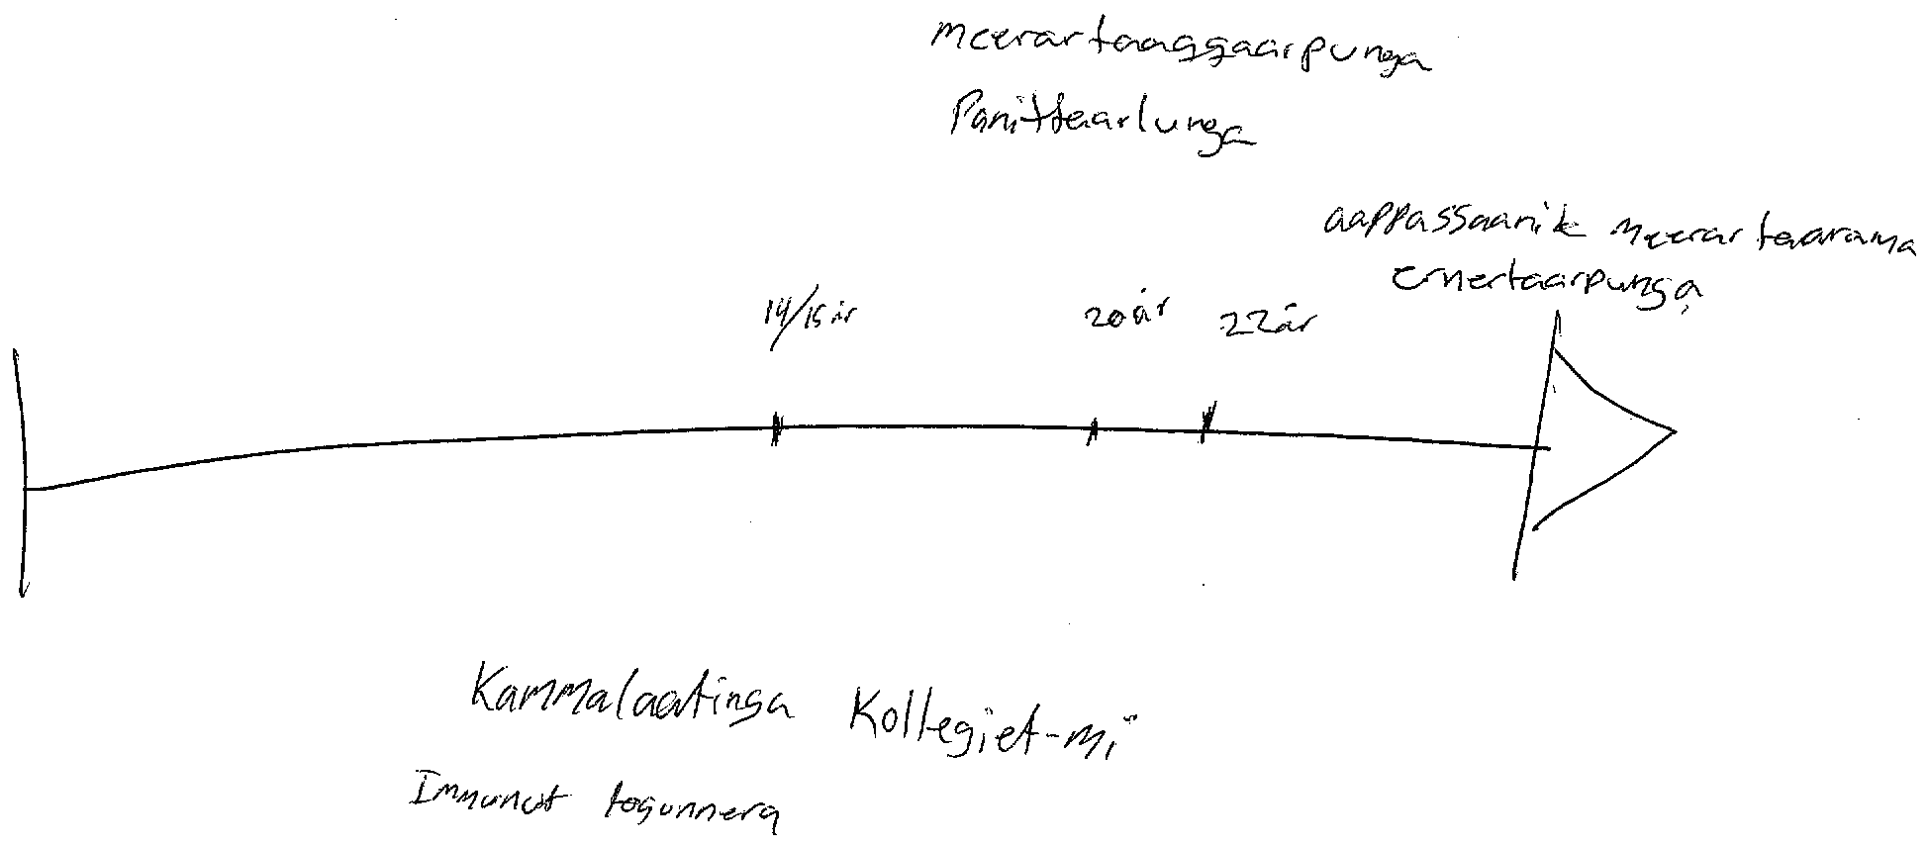

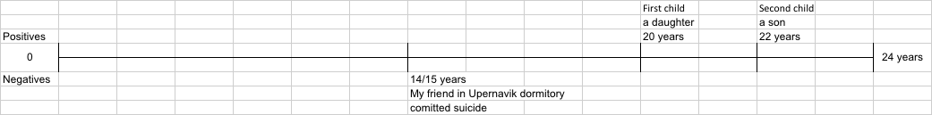

I don’t have too much recollection of my childhood.

Positive 14/15 years: Surely, in the beginning it was nice and joyful to be at Upernavik dormitory and leaving parents. I have had left my parents several times until today.

Negative 14/15 years: While we were in Upernavik dormitory we experienced something terrible, my close friend committed suicide.

Positive 20 years: I had my first child, a daughter. In the beginning I was unsure, surely, she was in a relationship with someone else while she was pregnant, it turned out to be mine after eight months’ pregnancy, having my first child made me happy.

Positive 22 years: I had my second child, a son with the woman I am in relationship with now. I started living with her during 2012. She had an abortion first time she got pregnant. After a while she got pregnant, it was while we were parted she had realized that she was pregnant, so we decided to get back together.

MDR: Are your parents alive? Yes, but these last few days there is something with my father, he gets angry all the time, it makes us sad but we also get happy.

MDR: Do you have any siblings? I have five siblings, but we don’t live with the two oldest siblings, they both live somewhere else, they live here.

MDR: Where are you among your siblings? I am the middle child.

MDR: Are your grandparent well? No, they were all gone even before I became aware.

I have no other things to mention.

MDR: Do you have any questions? Maybe, I could ask when you are expecting to be back?

ER: Next year at the end of March, after the Arctic Winter Games, because I don’t want to deal with that Greenland is going to be busy. End of March or all of April.

MDR: She will be asking different type of questions and she will be back three more times and she will bring different people. When the research is completed she will be presenting it and she will try to get your recommendations then send them along with her findings to the Greenland Government so that they can better the circumstances for people in Kullorsuaq. That is the purpose. Do you have other questions?

I have nothing else to add. The next one is exciting when it will be.

