WRF mapping for the coupler
Alice DuVivier – March 2013
alice.duvivier@colorado.edu
Files for WRF grids at 50km and 10km that cover the Arctic System domain have been created, and RACM has been tested using WRF with the 50km grid size. If a new mapping file needs to be created, then data from the new WRF domain needs to be provided to the coupler for creation of a mapping file.
A WRF grid requires a geo_em.d01.nc file from the WRF Pre-processing System (WPS). This file has all the data required to create a mapping file for the coupler. The coupler requires a netcdf file that has the following information for a WRF grid has nx points from east to west and ny points from south to north:
dimensions:
grid_size = nx*ny
grid_rank = 2
grid_corners = 4
variables:
integer grid_dims(grid_rank) = (nx,ny)
double grid_center_lat(gridsize)
grid_center_lat: units = “radians”
double grid_center_lon(gridsize)
grid_center_lon: units = “radians”
double grid_corner_lat(gridsize,grid_corners)
grid_center_lon: units = “radians”
double grid_corner_lon(gridsize,grid_corners)
grid_center_lon: units = “radians”
double grid_area(grid_size)
grid_center_lon: units = “radians^2”
integer grid_imask (grid_size)
grid_imask: units = “unitless”
Equal to 1 everywhere for WRF

The center latitude and longitude arrays correspond to the XLAT_M and XLONG_M for each grid point.
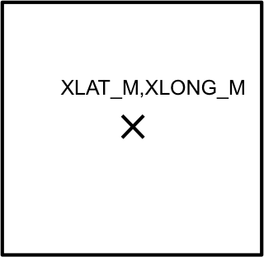
There are four corner latitude and longitudes for each grid point that are more complicated to calculate using the XLAT_U, XLAT_V, XLONG_U, XLONG_V arrays. Additionally, the corner points must be entered into the corner array in a counterclockwise direction (03) but it does not matter which corner you start with.
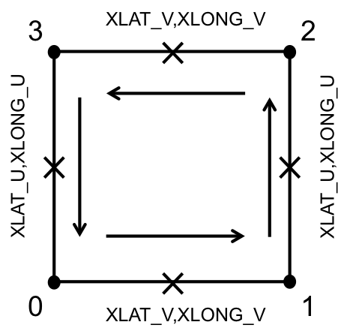
The idl script create_cpl_map.pro creates a netcdf file with the characteristics given above. It requires the additional scripts geo_midpt.pro and map_2points.pro. Open IDL at the command line and enter the following options:
idl>.compile geo_midpt.pro
idl>.compile map_2points.pro
idl>.compile create_cpl_map.pro
idl>create_cpl_map, /scrip, /cpl_ocean, /cpl_land
The following options in create_cpl_map.pro need to be changed manually:
- wrf_input this is the path where the WRF geo_em.d01.nc file is located.
- nc_out set the name for the WRF gridding file you are creating and the directory to which it will be written.
- nc_id set the name for an ocean or land gridding file the script creates and the directory to which it will be written. These files are not needed at this time.

The WRF gridding file that is created will need to be further processed to create a finalized mapping file that is used by the coupler.

